**Machine learning-****assisted exploration of the intrinsic factors affecting the catalytic activity of ORR/OER bifunctional catalysts**

Ninggui Maa, Yaqin Zhanga, Yuhang Wanga, Changxiong Huanga, Jun Zhaoa, Bochun Liang a, Jun Fana, b, c *

*a* *Department of Materials Science and Engineering, City University of Hong Kong,* *Hong Kong, China*

*b Department of Mechanical Engineering, City University of Hong Kong, Hong Kong, China*

*c Center for Advanced Nuclear Safety and Sustainable Development, City University of Hong Kong, Hong Kong, China*

*Corresponding author. E-mail: junfan@cityu.edu.hk (Jun Fan)

Fig. S1 The structure of Ti2CO2.

**Fig. S2** The phonon dispersion of the NTiCO2. N=3*d* and 4*d* transition metals.

**Fig. S3** Oscillation of free energy against time in AIMD simulation of NTiCO2 monolayer under 500 K over the time scale of 10 ps with the time step of 2 fs. N=3*d* transition metals.

**Fig. S4** Oscillation of free energy against time in AIMD simulation of NTiCO2 monolayer under 500 K over the time scale of 10 ps with the time step of 2 fs. N=4*d* transition metals.

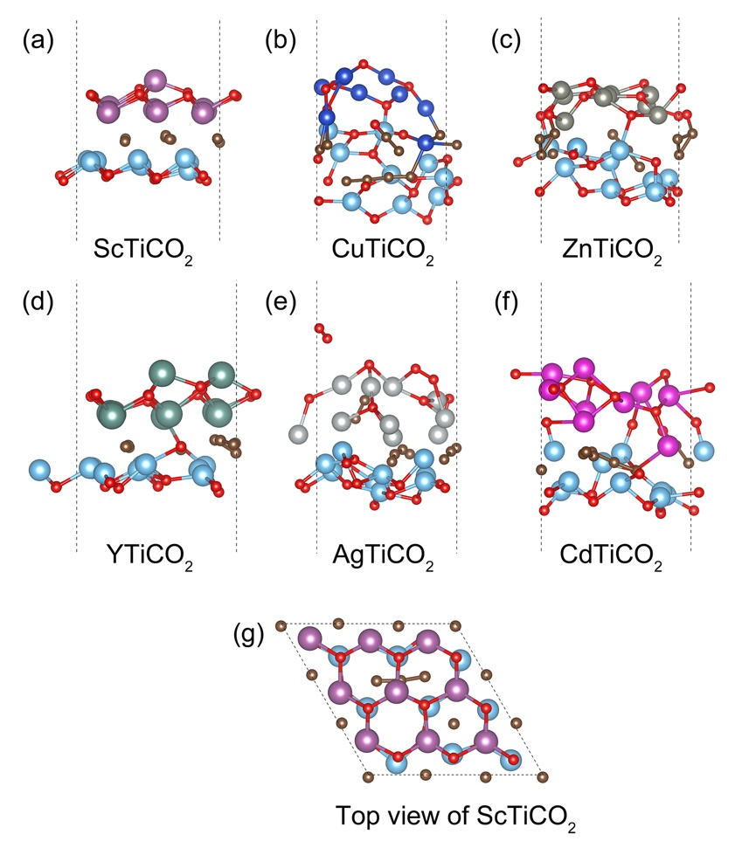

Fig. S5 The unstable structure of NTiCO2 after 10 ps AIMD simulation under 500 K.

In the Fig. S5(g), the C atoms in the middle deviate from the equilibrium position and form a C chain. This causes the ScTiCO2 structure to start reorganizing.

Fig. S6 The structure of the RuTiCO2.

**Fig. S7** The variation free energy for RuTiCO2 with 300 K (a), 400 K (b) and 450 K (c) in the AIMD simulations, which with the time scale of 10 ps. The structure of RuTiCO2 after 10 ps AIMD simulation under 300 K (d), 400 K (e) and 450 K (f).

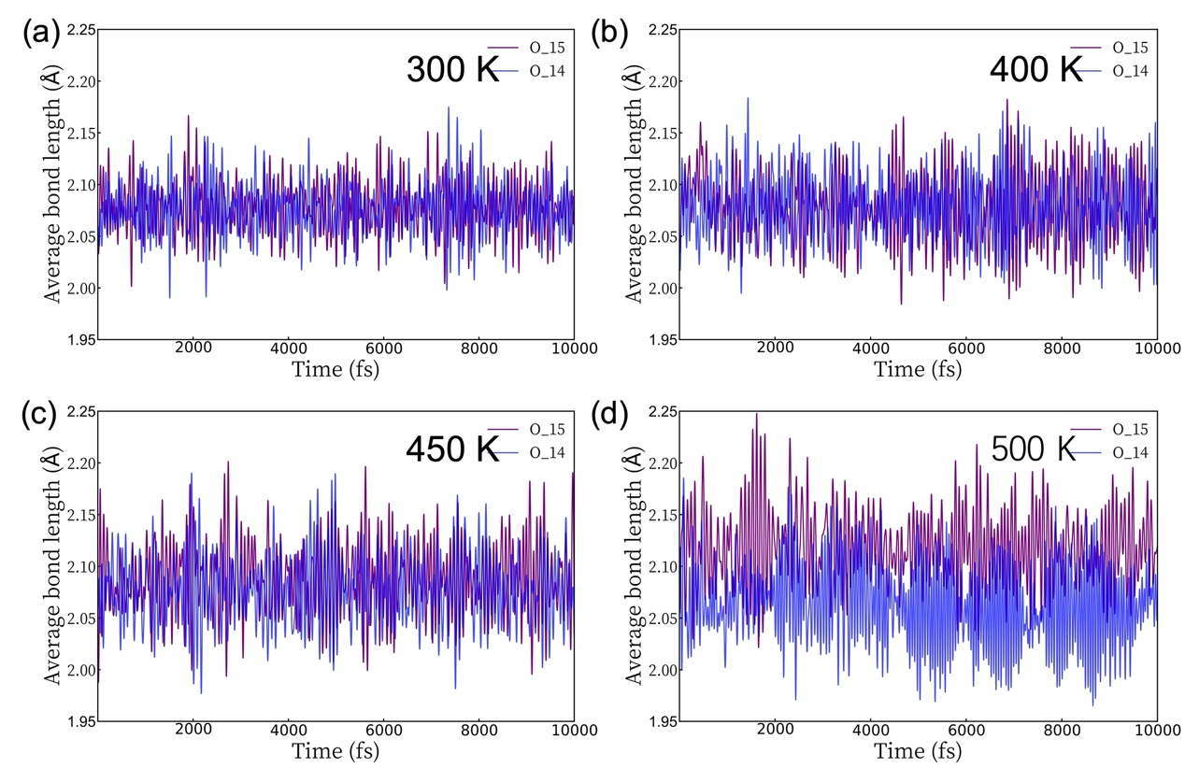

Fig. S8 The variation bond lengths of Ru-O14 and Ru-O15 in RuTiCO2 under the 300 K (a), 400 K (b), 450 K (c) and 500 K (d), which with the time scale of 10 ps.

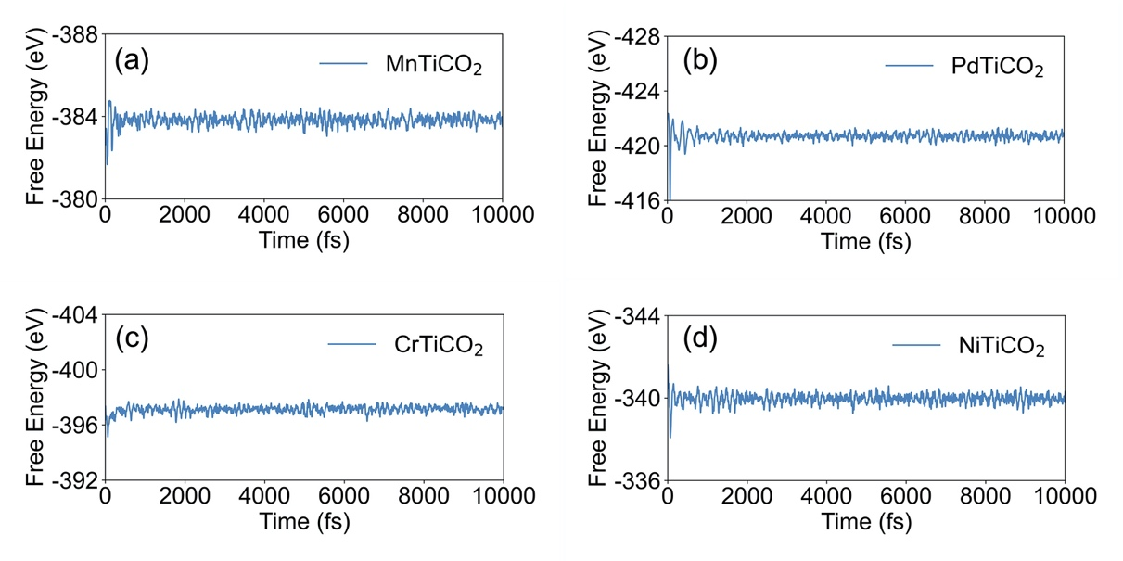

**Fig. S9** Oscillation of free energy against time in AIMD simulation of NTiCO2 monolayer under 300 K over the time scale of 10 ps with the time step of 2 fs. N=Mn, Pd, Cr and Ni.

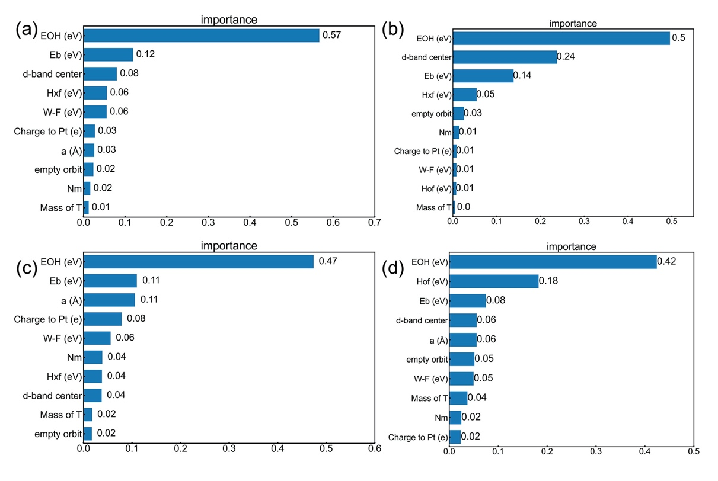

Fig. S10 The feature importance of the top 10 input features in the RFR (a) and XGBR (b) models for ORR. The feature importance of the top 10 input features in the RFR (a) and XGBR (b) models for OER.

**Table S1** Cohesive energy of 3*d* dual transition metal Janus-MXenes.

|  |  |  |  |  |  |  |  |  |  |  |
| --- | --- | --- | --- | --- | --- | --- | --- | --- | --- | --- |
| N= | Sc | Ti | V | Cr | Mn | Fe | Co | Ni | Cu | Zn |
| $E_{N}$ (eV) | -2.01 | -2.38 | -3.56 | -5.45 | -5.15 | -3.32 | -1.70 | -0.60 | -0.24 | -0.01 |
| $E_{Ti}$ (eV) | -2.38 | -2.38 | -2.38 | -2.38 | -2.38 | -2.38 | -2.38 | -2.38 | -2.38 | -2.38 |
| $E_{C}$ (eV) | -1.23 | -1.23 | -1.23 | -1.23 | -1.23 | -1.23 | -1.23 | -1.23 | -1.23 | -1.23 |
| $E_{O}$ (eV) | -1.91 | -1.91 | -1.91 | -1.91 | -1.91 | -1.91 | -1.91 | -1.91 | -1.91 | -1.91 |
| $E_{{NTiCO}_{2}}$ (eV) | -388.16 | -411.67 | -407.58 | -400.63 | -390.93 | -374.20 | -358.16 | -340.86 | -309.95 | -288.50 |
| $E_{coh}$ (eV) | 6.74 | 7.18 | 6.86 | 6.32 | 6.17 | 6.16 | 6.13 | 5.97 | 5.35 | 4.92 |

**Table S2** Cohesive energy of 4*d* dual transition metal Janus-MXenes.

|  |  |  |  |  |  |  |  |  |  |  |
| --- | --- | --- | --- | --- | --- | --- | --- | --- | --- | --- |
| N= | Y | Zr | Nb | Mo | Tc | Ru | Rh | Pd | Ag | Cd |
| $E_{N}$ (eV) | -2.13 | -2.25 | -3.16 | -4.65 | -3.26 | -2.22 | -1.24 | -1.48 | -0.20 | -0.01 |
| $E_{Ti}$ (eV) | -2.38 | -2.38 | -2.38 | -2.38 | -2.38 | -2.38 | -2.38 | -2.38 | -2.38 | -2.38 |
| $E_{C}$ (eV) | -1.23 | -1.23 | -1.23 | -1.23 | -1.23 | -1.23 | -1.23 | -1.23 | -1.23 | -1.23 |
| $E_{O}$ (eV) | -1.91 | -1.91 | -1.91 | -1.91 | -1.91 | -1.91 | -1.91 | -1.91 | -1.91 | -1.91 |
| $E_{{NTiCO}_{2}}$ (eV) | -382.83 | -419.02 | -424.87 | -417.10 | -400.40 | -381.02 | -359.80 | -334.29 | -291.16 | -274.39 |
| $E_{coh}$ (eV) | 6.59 | 7.37 | 7.32 | 6.85 | 6.76 | 6.53 | 6.26 | 5.64 | 4.94 | 4.61 |

**Table S3** The formation energy, binding energy of Pt atom on the O vacancy of NTiCO2 and band-gap of Pt-VO-NTiCO2.

|  |  |  |  |  |  |  |  |  |  |  |
| --- | --- | --- | --- | --- | --- | --- | --- | --- | --- | --- |
| N= | Sc | Ti | V | Cr | Mn | Fe | Co | Ni | Cu | Zn |
| ${ E}_{b}$ (eV) | -- | -5.78 | -- | -4.32 | -5.01 | -4.57 | -4.28 | -4.66 | -- | -- |
| $E_{form}$ (eV) | -- | 4.67 | -- | 2.34 | 2.39 | 1.10 | 0.25 | 0.52 | -- | -- |
| Band-gap (eV) | -- | 0 | -- | 0 | 0.21 | 0.02 | 0 | 0.65 | -- | -- |
| N= | Y | Zr | Nb | Mo | Tc | Ru | Rh | Pd | Ag | Cd |
| $E_{b}$ (eV) | -- | -6.28 | -5.98 | -5.31 | -5.50 | -4.78 | -4.19 | -4.72 | -- | -- |
| $E_{form}$ (eV) | -- | 5.45 | 4.55 | 2.20 | 0.49 | 0.17 | -0.59 | 0.53 | -- | -- |
| Band-gap (eV) | -- | 0.76 | 0 | 0.10 | 0 | 0 | 0 | 0.78 | -- | -- |

Table S4 The dissolution potential of Pt doped DTM MXenes-based SACs.

|  |  |  |  |  |  |  |
| --- | --- | --- | --- | --- | --- | --- |
| N= | Ti | V | Cr | Mn | Fe | Co |
| $U_{diss}$ (eV) | 0.62 | 0.72 | 0.45 | 0.79 | 0.57 | 0.43 |
| N= | Zr | Nb | Mo | Tc | Ru | Rh |
| $U_{diss}$ (eV) | 1.42 | 1.28 | 0.93 | 1.04 | 0.68 | 0.38 |

**Table S4.** The Gibbs free energy of each step on the Pt-VO-Ti2CO2 toward ORR, OER and HER

|  |  |  |  |  |  |  |  |
| --- | --- | --- | --- | --- | --- | --- | --- |
| Materials | $∆G_{*OH}$ (eV) | $∆G_{*O}$ (eV) | $∆G_{*OOH}$ (eV) | $η^{ORR}$ (V) | $η^{OER}$ (V) | $η^{Bi}$ (V) | $η^{H}$ (V) |
| Pt-VO-Ti2CO2 | 1.17 | 3.10 | 4.29 | 0.60 | 0.70 | 1.30 | 0.94 |
| Pt-VO-CrTiCO2 | 0.79 | 2.34 | 3.89 | 0.52 | 0.44 | 0.33 | 0.77 |
| Pt-VO-MnTiCO2 | 0.99 | 2.61 | 3.92 | 0.48 | 0.24 | 0.38 | 0.62 |
| Pt-VO-FeTiCO2 | 0.71 | 2.34 | 3.76 | 0.73 | 0.52 | 0.41 | 0.93 |
| Pt-VO-CoTiCO2 | -1.03 | 2.34 | 3.60 | 0.53 | 2.26 | 2.14 | 4.40 |
| Pt-VO-NiTiCO2 | 0.82 | 2.43 | 3.81 | 0.46 | 0.41 | 0.38 | 0.79 |
| Pt-VO-ZrTiCO2 | 1.35 | 3.19 | 4.35 | 0.56 | 0.57 | 0.62 | 1.19 |
| Pt-VO-NbTiCO2 | 0.53 | 2.00 | 3.79 | 0.91 | 0.69 | 0.56 | 1.25 |
| Pt-VO-MoTiCO2 | 0.97 | 2.77 | 4.11 | 0.38 | 0.42 | 0.56 | 0.98 |
| Pt-VO-TcTiCO2 | 0.24 | 1.76 | 3.45 | 0.65 | 0.99 | 0.47 | 1.46 |
| Pt-VO-RuTiCO2 | -0.60 | 0.93 | 2.40 | 0.46 | 1.83 | 0.30 | 2.13 |
| Pt-VO-RhTiCO2 | 0.65 | 1.14 | 3.63 | 0.61 | 0.58 | 1.25 | 1.83 |
| Pt-VO-PdTiCO2 | 0.90 | 2.48 | 3.89 | 0.53 | 0.33 | 0.36 | 0.69 |

**Table S5.** The overpotential for ORR and OER bifunctional activity of catalysts in our work and some representative references.

|  |  |  |  |  |
| --- | --- | --- | --- | --- |
| Materials | $E^{ORR}$ (V) | $E^{OER}$ (V) | $η^{Bi}$ (V) | $η^{ORR}$ (V) |
| Pt-VO-CrTiCO2 | 0.79 | 1.56 | 0.77 | This work |
| Pt-VO-MnTiCO2 | 0.99 | 1.61 | 0.62 | This work |
| Pt-VO-NiTiCO2 | 0.82 | 1.61 | 0.79 | This work |
| Pt-VO-PdTiCO2 | 0.90 | 1.59 | 0.69 | This work |
| NiCo2O4/C | 0.80 | 1.61 | 0.81 | Ref. [1] |
| 1D-Co2O4 | 0.78 | 1.63 | 0.84 | Ref. [2] |
| Ni/NiO | 0.74 | 1.53 | 0.79 | Ref. [3] |
| NiO/CoN | 0.68 | 1.53 | 0.85 | Ref. [4] |
| 20% Ir/C | 0.69 | 1.61 | 0.92 | Ref. [5] |
| Ni1&Ni2-Ti2CO2 | 0.79 | 1.65 | 0.86 | Ref. [6] |
| Co1&Ni2- Ti2CO2 | 0.67 | 1.71 | 0.94 | Ref. [6] |

**Table S7** Features of Pt doped DTM MXenes-based SACs

|  |  |  |  |  |  |  |  |  |  |  |  |  |  |
| --- | --- | --- | --- | --- | --- | --- | --- | --- | --- | --- | --- | --- | --- |
| Materials | a (Å) | Mass of T | Nm | Hof (eV) | Hxf (eV) | Im (eV) | W-F (eV) | Charge to Pt (e) | d-band center | empty orbit | Eb (eV) | electron affinict | EOH (eV) |
| Pt-VO-Ti2CO2 | 9.06 | 16 | 3.44 | -11.39 | -13.05 | 6.828 | 5.4 | -0.01 | -1.92 | 2 | -5.78 | 1.54 | 0.9 |
| Pt-VS-Ti2CS2 | 9.53 | 32 | 2.58 | -11.39 | -13.05 | 6.828 | 5.83 | 0.27 | -1.67 | 2 | -5.29 | 1.54 | 0.92 |
| Pt-VSe-Ti2CSe2 | 9.66 | 78.9 | 2.55 | -11.39 | -13.05 | 6.828 | 5.2 | 0.45 | -1.97 | 2 | -5.65 | 1.54 | 0.79 |
| Pt-VF-Ti2CF2 | 9.12 | 18.99 | 3.98 | -11.39 | -13.05 | 6.828 | 4.62 | 0.35 | -2.07 | 1 | -6.28 | 1.54 | 0.22 |
| Pt-VCl-Ti2CCl2 | 9.65 | 35.45 | 3.16 | -11.39 | -13.05 | 6.828 | 4.47 | 0.42 | -1.97 | 1 | -5.62 | 1.54 | 0.37 |
| Pt-VBr-Ti2CBr2 | 9.9 | 79.9 | 2.96 | -11.39 | -13.05 | 6.828 | 4.27 | 0.54 | -1.94 | 1 | -5.59 | 1.54 | 0.46 |
| Pt-VI-Ti2CI2 | 10.33 | 126.91 | 2.66 | -11.39 | -13.05 | 6.828 | 3.98 | 0.06 | -1.92 | 1 | -5.72 | 1.54 | 0.33 |
| Pt-VF-Ti2COF | 9.04 | 18.99 | 3.71 | -11.39 | -13.05 | 6.828 | 5.28 | 0.15 | -1.83 | 1 | -5.39 | 1.54 | 0.08 |
| Pt-VO-Ti2COF | 9.04 | 16 | 3.71 | -11.39 | -13.05 | 6.828 | 4.81 | 0.17 | -2.412 | 2 | -6.76 | 1.54 | -0.05 |
| Pt-VCl-Ti2COCl | 9.28 | 35.45 | 3.3 | -11.39 | -13.05 | 6.828 | 4.49 | 0.14 | -2.32 | 1 | -5.82 | 1.54 | 0.51 |
| Pt-VO-Ti2COCl | 9.28 | 16 | 3.3 | -11.39 | -13.05 | 6.828 | 4.88 | 0.22 | -2.32 | 2 | -5.38 | 1.54 | 0.42 |
| Pt-VBr-Ti2COBr | 9.42 | 79.9 | 3.2 | -11.39 | -13.05 | 6.828 | 4.18 | 0.39 | -2.36 | 1 | -5.52 | 1.54 | 0.29 |
| Pt-VO-Ti2COBr | 9.42 | 16 | 3.2 | -11.39 | -13.05 | 6.828 | 4.87 | 0.25 | -1.81 | 2 | -5.52 | 1.54 | 0.37 |
| Pt-VI-Ti2COI | 9.67 | 126.91 | 3.05 | -11.39 | -13.05 | 6.828 | 3.73 | 0.64 | -2.46 | 1 | -5.8 | 1.54 | 0.3 |
| Pt-VO-Ti2COI | 9.67 | 16 | 3.05 | -11.39 | -13.05 | 6.828 | 4.69 | 0.44 | -2.14 | 2 | -5.53 | 1.54 | 0.03 |
| Pt-VF-Ti2CSF | 9.36 | 18.99 | 3.28 | -11.39 | -13.05 | 6.828 | 4.80 | 0.24 | -2.28 | 1 | -6.60 | 1.54 | 0.06 |
| Pt-VS-Ti2CSF | 9.36 | 32 | 3.28 | -11.39 | -13.05 | 6.828 | 5.46 | 0.15 | -1.68 | 2 | -5.14 | 1.54 | 0.83 |
| Pt-VCl-Ti2CSCl | 9.59 | 35.45 | 2.87 | -11.39 | -13.05 | 6.828 | 4.68 | 0.4 | -2.15 | 1 | -5.77 | 1.54 | 0.26 |
| Pt-VS-Ti2CSCl | 9.59 | 32 | 2.87 | -11.39 | -13.05 | 6.828 | 5.49 | 0.4 | -1.65 | 2 | -5.14 | 1.54 | 0.79 |
| Pt-VBr-Ti2CSBr | 9.74 | 79.9 | 2.77 | -11.39 | -13.05 | 6.828 | 4.48 | 0.32 | -2.19 | 1 | -5.70 | 1.54 | 0.3 |
| Pt-VS-Ti2CSBr | 9.74 | 32 | 2.77 | -11.39 | -13.05 | 6.828 | 5.45 | 0.46 | -1.665 | 2 | -5.17 | 1.54 | 0.63 |
| Pt-VI-Ti2CSI | 9.98 | 126.91 | 2.62 | -11.39 | -13.05 | 6.828 | 4.17 | 0.84 | -2.177 | 1 | -5.83 | 1.54 | 0.31 |
| Pt-VS-Ti2CSI | 9.98 | 32 | 2.62 | -11.39 | -13.05 | 6.828 | 5.38 | 0.51 | -1.74 | 2 | -5.25 | 1.54 | 0.33 |
| Pt-VF-Ti2CSeF | 9.36 | 18.99 | 3.265 | -11.39 | -13.05 | 6.828 | 4.69 | 0.35 | -2.24 | 1 | -6.51 | 1.54 | 0.13 |
| Pt-VSe-Ti2CSeF | 9.36 | 78.9 | 3.265 | -11.39 | -13.05 | 6.828 | 4.94 | 0.23 | -2.04 | 2 | -5.77 | 1.54 | 0.83 |
| Pt-VCl-Ti2CSeCl | 9.62 | 35.45 | 2.855 | -11.39 | -13.05 | 6.828 | 4.6 | 0.37 | -2.1 | 1 | -5.75 | 1.54 | 0.31 |
| Pt-VSe-Ti2CSeCl | 9.62 | 78.9 | 2.855 | -11.39 | -13.05 | 6.828 | 5.09 | 0.32 | -1.9 | 2 | -5.58 | 1.54 | 0.82 |
| Pt-VBr-Ti2CSeBr | 9.78 | 79.9 | 2.755 | -11.39 | -13.05 | 6.828 | 4.41 | 0.5 | -2.1 | 1 | -5.69 | 1.54 | 0.33 |
| Pt-VSe-Ti2CSeBr | 9.78 | 78.9 | 2.755 | -11.39 | -13.05 | 6.828 | 5.1 | 0.4 | -1.84 | 2 | -5.42 | 1.54 | 0.79 |
| Pt-VI-Ti2CSeI | 10.05 | 126.91 | 2.605 | -11.39 | -13.05 | 6.828 | 4.11 | 0.52 | -2.16 | 1 | -5.83 | 1.54 | 0.33 |
| Pt-VSe-Ti2CSeI | 10.05 | 78.9 | 2.605 | -11.39 | -13.05 | 6.828 | 5.14 | 0.6 | -1.78 | 2 | -5.26 | 1.54 | 0.36 |
| Pt-VO-VTiCO2 | 8.86 | 16 | 3.44 | -9.77 | -10.85 | 6.787 | 5.87 | 0.39 | -1.68 | 2 | -4.87 | 1.59 | 0.42 |
| Pt-VO-CrTiCO2 | 8.9 | 16 | 3.44 | -8.825 | -11.49 | 6.798 | 5.77 | 0.32 | -1.51 | 2 | -4.32 | 1.6 | 0.44 |
| Pt-VO-MnTiCO2 | 8.93 | 16 | 3.44 | -8.44 | -10.38 | 7.131 | 6.11 | 0.04 | -1.52 | 2 | -5.01 | 1.55 | 0.62 |
| Pt-VO-FeTiCO2 | 8.83 | 16 | 3.44 | -8.915 | -10.69 | 7.366 | 6.43 | 0.45 | -1.27 | 2 | -4.57 | 1.69 | 0.32 |
| Pt-VO-NiTiCO2 | 8.94 | 16 | 3.44 | -8.07 | -10.47 | 7.234 | 5.77 | 0.08 | -1.2 | 2 | -4.66 | 1.73 | 0.46 |
| Pt-VO-ZrTiCO2 | 9.52 | 16 | 3.44 | -4.035 | -13.83 | 6.731 | 5.18 | 0.36 | -1.76 | 2 | -6.28 | 1.44 | 1.02 |
| Pt-VO-NbTiCO2 | 9.17 | 16 | 3.44 | -11.73 | -15.39 | 6.794 | 5.36 | 0.18 | -2.11 | 2 | -5.98 | 1.57 | 0.17 |
| Pt-VO-MoTiCO2 | 8.99 | 16 | 3.44 | -9.55 | -13.83 | 6.96 | 5.52 | 0.64 | -2.06 | 2 | -5.31 | 1.85 | 0.62 |
| Pt-VO-TcTiCO2 | 8.98 | 16 | 3.44 | -8.765 | -9.76 | 7.054 | 5.97 | 0.04 | -1.42 | 2 | -5.5 | 1.73 | -0.12 |
| Pt-VO-RuTiCO2 | 9.1 | 16 | 3.44 | -8.76 | -12.73 | 7.095 | 6.16 | -0.23 | -1.5 | 2 | -4.78 | 1.87 | -0.96 |
| Pt-VO-PdTiCO2 | 9.26 | 16 | 3.44 | -7.1 | -9.865 | 7.583 | 6.5 | -0.44 | -1.09 | 2 | -4.72 | 1.87 | 0.51 |

Computational details

The cohesive energy of DTM Janus-MXenes is calculated by the equation of:

$E_{c}=\left[9\left(E_{N}+E_{Ti}+E_{C}\right)+18\left(E_{O}\right)-E_{{NTiCO}_{2}}\right]/45$ (1)

Where, the $E_{N}$, $E_{Ti}$, $E_{C}$ and $E_{O}$ are the energy of single atom of N (3*d* and 4*d* transition metal atoms), Ti, C and O atom, respectively. $E_{{NTiCO}_{2}}$ is the total energy of 3×3×1 NTiCO2 structure.

The vacancy formation energy of O atom in DTM Janus-MXenes can be calculation by follow equation:

$E_{form}=E_{V-O}+E_{O}-E_{MXene}$ (2)

Where, the $E_{V-O}$, $E_{O}$ and $E_{MXene}$ are the total energy of the Janus-Mxenes with single O vacancy, the energy of the single atom of molecular and the total energy of prefect Janus-MXenes, respectively.

The binding energy of Pt atom on the O vacancy of DTM Janus-MXenes was represented as:

${ E}_{b}={ E}_{slab}-{ E}_{V-O}-{ E}_{Pt}$ (3)

Where ${ E}_{slab}$, ${ E}_{V-O}$ and ${ E}_{Pt}$ are the total energy of Pt-doped Janus-MXenes, the total energy of the Janus-MXenes with single O vacancy and single Pt atoms in a vacuum, respectively. In general, the more negative the binding energy represent, the stronger interaction between the Pt atoms and NTiCO2-VO.

The adsorption energy is calculated by the following expression:

${ E}_{ads}={ E}_{*ad}-{ E}_{slab}-{ E}_{ad}$ (4)

Where ${ E}_{*ad}$ is the total energy of the Pt-doped Janus-MXenes with catalytic intermediates, ${ E}_{slab}$ is the total energy of Pt-doped Janus-MXene. ${ E}_{ad}$ is energy of the catalytic intermediate.

The Gibbs free energy ($∆G$) for each electronic step is defined as:

$∆G=∆E+{∆E}_{ZPE}-T∆S$ (4)

Where, $∆E$, ${∆E}_{ZPE}$ and $T∆S$ is the adsorption energy, the difference of zero-point energies and the entropy between the adsorbed state and the free-standing state, respectively. (T=298.15 K).[7]

The overpotential for the bifunctional ORR/OER is defined as:

$∆E^{Bi}= E^{OER}-E^{ORR}$ (5)

Where the $E^{OER}$ is the potential of the rate determining step (RDS) for OER and $E^{ORR}$ is the potential of the RDS for ORR.

In present work, we consider the ORR and OER in acidic solutions. The total reactions for ORR and OER can be expressed as the equations (4) and (5) as following:

O2 + 4H+ +4e- →2H2O (6)

2H2O →O2 + 4H+ +4e- (7)

The 4e‑ association mechanism for ORR is described by formula 6a-6d

*+ O2 (g) +e- + H+ →*OOH (6a)

*OOH + e- +H+ → H2O (I)+*O (6b)

*O + e- H+ → *OH (6c)

*OH + e- + H+ → H2O (l) (6d)

The 4e‑ association mechanism for OER is represented by formula 7a-7d

H2O + *→*OH + e- + H+  (7a)

*OH →*O + e- + H+ (7b)

H2O (l)+*O →*OOH + e- +H+ (7c)

*OOH →*+ O2(g) +e- + H+ (7d)

Here, * denoted the catalysts. In addition, we are using the (l) and (g) to expresses the liquid and gas phases, respectively. The adsorption energy of O, OH and OOH are calculated by following equations:

$∆E_{O^{*}}=E_{O^{*}}-E_{*}-(E_{H_{2}O}-E_{H_{2}})$ (8)

$∆E_{*OH}=E_{*OH}-E_{*}-(E_{H_{2}O}-\frac{1}{2}E_{H_{2}})$ (9)

$∆E_{*OOH}=E_{*OOH}-E_{*}-({2E}_{H_{2}O}-\frac{3}{2}E_{H_{2}})$ (10)

Herein, the $E_{O^{*}}$, $E_{{OH}^{*}}$, $E_{{OOH}^{*}}$ and $E_{*}$ is the total energy of SACs with O, OH, OOH and without adsorbent. The $E_{H_{2}O}$ and $E_{H_{2}}$ are the total energies of free H2O and H2 molecules in liquid and gas phases, respectively. $∆G$ (the Gibbs free energy) is defined by equation (11):

$∆G= ∆E+ ∆ZPE-T∆S+∆G_{u}+ ∆G_{pH}$ (11)

$∆ZPE$ and $∆S$ is the zero-point energy and the entropy. The $∆ZPE$ could be obtained by calculating the vibrational frequencies of the adsorbed species. $∆G_{u}$ =-neU, where n was the number of electrons transferred and U was the electrode potential. For the acidic solutions, the pH is set to zero and $G_{pH}$ is refer to the corrected free energy. As for the gas phase molecules, the ZPE can obtain form the NIST database. In this work, we use the 1/2H2 to represent the free energy of (H+ +e-). Because DFT has limitations in calculating the triplet state of O2, the Gibbs free energy of O2 is expressed by:

$G_{O_{2}}={2G}_{H_{2}O}+2G_{H_{2}}-4*1.23 (eV)$ (12)

By calculating the $∆G$ of each reaction step, we can obtain the rate-determining step of ORR and OER. The method of calculation overpotential of ORR and OER are shown in equation (13) and (14):

${∆G}_{max}^{ORR}=\max{ \{{∆G}_{a}}, {∆G}_{b}, {∆G}_{c}, {∆G}_{d}\}+1.23 V$ (13)

${∆G}_{max}^{OER}=\max{ \{{-∆G}_{a}}, {-∆G}_{b}, {-∆G}_{c},-{∆G}_{d}\}+1.23 V$ (14)

The dissolution potential is defined as follow equation:

$U_{diss}=U_{diss-bulk}-{E_{cluster}}/{n_{e}}$ (15)

Where the $U_{diss}$ and $U_{diss-bulk}$ are the dissolution potential and standard electrode potential, which are looked up from the handbook of chemistry and physics.(Acree, W. E. NIST Chemistry Webbook, NIST Standard Reference Database No. 69; National Institute of Standards and Technology: Gaithersburg, MD, 2018; http://webbook.nist.gov/ chemistry (accessed May 10, 2021)). $n_{e}$ is the number of transferred electrons during the dissolution reaction. A solution potential ($U_{diss}$) greater than 0 indicates that the material is electrochemically stable. $E_{cluster}$ is the cluster energy, which mean that the aggregation possibility of TM atoms on Pt-VO-NTiCO2. The cluster energy is represented by the equation of:

$E_{cluster}=E_{binding}-E_{coh}$ (16)

$E_{binding}$ and $E_{coh}$ are the binding energy of TM on substrate and the cohesive energy, respectively. $E_{coh-Pt}=E_{TM-bulk}/n-E_{TM-single}$ (17)

$E_{TM-bulk}$ and $E_{TM-single}$ are the total energy of TM in bulk and the total energy of single TM in vacuum, respectively.

**Random Forest Regression (RFR)** model is an ensemble learning method for regression by constructing a multitude of decision trees at training time and outputting the class that is the mode of the classes (classification) or mean/average prediction (regression) of the individual trees.6 Random decision forests correct for decision trees' habit of overfitting to their training set. The training algorithm for random forests applies the general technique of bootstrap aggregating, or bagging, to tree learners. Given a training set X = x1... xn with responses Y = y1... yn, bagging repeatedly (B times) selects a random sample with replacement of the training set and fits trees to these samples:

1. For b = 1... B: Sample, with replacement, n training examples from X, Y; call these Xb, Yb; Train a regression tree fb on Xb, Yb.
2. After training, predictions for unseen samples x' can be made by averaging the predictions from all the individual regression trees on x'

$$\hat{f}= \frac{1}{B} \sum_{b=1}^{B}{f_{b}\left(x^{'}\right) (18)}$$

The **Extreme** **Gradient Boosted Regression (XGBR)** model is an integrated ML algorithm that is generated by the integration of weak regression trees.1,2 Given the training samples 𝑫 = {(𝐱𝟏, 𝐲𝟏), (𝐱𝟐, 𝐲𝟐) …, (𝐱𝐧, 𝐲𝐧)}, the number of leaf nodes in every regression tree is ***J***. We divided the input data into J disjoint areas and defined each regression tree as **tm(x)**. The training goal of GBR is to minimize the loss function ***L***, and the parameters of decision tree 𝛉𝐦 are determined through empirical risk minimization:

$$θ_{m}={}_{θ_{m}}^{argmin}{\sum_{i=1}^{n}{L\left(y_{i}, f_{\left(m-1\right)}\left(x_{i}\right)+t_{m}\left(x_{i}\right)\right) (19) }}$$

The process of GBR training is as follows:

(a) Initialize a regression tree function 𝑓0 (𝑥).

(b) Train GBR in the gradient decline direction, and compute the negative gradient value of the loss function as the estimated value of the residual. For the mth iteration, GBR generates a regression tree according to the residual and updates the current function 𝑓m (𝑥).

(c) The final regression model is the weighted sum of several weak regression trees, which is defined as:

**RuTiO2 Stability Discussion:**

We further study the motion trajectories during AIMD simulation (Video 1). The results show that only one O atom (O14) of RuTiO2 deviates from the equilibrium position, forming a Franck defect (Fig. S6). Based on this result, AIMD of RuTiO2 at 300 K, 400 K and 450 K is implemented. RuTiO2 maintains energy stability and structural integrity in the simulations at three different temperatures above (Fig. S7). Furthermore, we compared the average bond length evolution of Ru-O14 and Ru-O15 under 300, 400, 450 and 500 K simulations. The results show that O14 deviates from the equilibrium position and forms shorter Ru-O bonds with adjacent Ru atoms at 500K, resulting in energy changes rather than structural reorganization. Therefore, we believe that RuTiCO2 is still stable at 500 K.

**ML Code:**

**XGBR model:**

**#XGBR**

*import numpy as np*

*import pandas as pd*

*from sklearn import linear_model*

*from sklearn.metrics import mean_squared_error, mean_absolute_error, r2_score # RMSE*

*import matplotlib.pyplot as plt*

*from sklearn.model_selection import cross_val_score*

*from sklearn.model_selection import KFold*

*from xgboost import XGBRegressor*

*import time*

*from sklearn.model_selection import train_test_split*

*df = data_training = pd.read_csv('ORR.csv')*

*features = df.iloc[:,0:-1]*

*target = df.iloc[:, -1]*

*X_train, X_test, y_train, y_test = train_test_split(features, target, train_size= 0.9, random_state=68)*

*#XGBR ML begin*

*from xgboost import XGBRegressor*

*from xgboost import plot_importance*

*# build model*

*KNR = xgbr = XGBRegressor()*

*kfold = KFold(n_splits=5, shuffle=True, random_state=42)*

*scores = cross_val_score(xgbr, X_train, y_train, scoring='neg_mean_squared_error', cv=kfold)*

*mse_ads = [abs(s) for s in scores]*

*mse_tr = np.mean(mse_ads)*

*rmse_scores = [np.sqrt(abs(s)) for s in scores]*

*xgbr.fit(X_train, y_train)*

*y_tr_pred = xgbr.predict(X_train)*

*MSE = mean_squared_error(y_tr_pred, y_train)*

*print ("MSE for test: {:.8f} eV".format(MSE)) #for train*

*R_squr1 = r2_score(y_tr_pred, y_train)*

*print (R_squr1) #for train*

*MSE = mean_squared_error(y_tr_pred, y_train)*

*RMSE = MSE**0.5*

*print ('RMSE: {:.4f} eV'.format(RMSE))*

*# Model testing*

*y_te_pred = xgbr.predict(X_test)*

*MSE = mean_squared_error(y_te_pred, y_test)*

*print ("MSE for test: {:.8f} eV".format(MSE)) # For testing*

*RMSE = MSE**.5*

*print ('RMSE for test {:.4f} eV'.format(RMSE)) #For testing*

*R_squr = r2_score(y_te_pred, y_test)*

*print ('R^2 for test {:.4f} eV'.format(R_squr)) #for testing*

*#get figure*

*font = {'family': 'serif',*

*'serif': 'Arial',*

*'weight': 'normal',*

*'size': 22}*

*plt.rc('font', **font)*

*fig, ax = plt.subplots(figsize=(8, 6))*

*ax.scatter(y_train, y_tr_pred, alpha=0.5, c='b', marker='o', label='Training')*

*ax.scatter(y_test, y_te_pred, alpha=0.5, c='r', marker='o', label='Test')*

*plt.xlim(-0.02, 1)*

*plt.ylim(-0.02, 1)*

*ax.set_xlabel('DFT (eV)', size = 26)*

*ax.set_ylabel('Prediction (eV)', size = 26)*

*ax.tick_params(axis='x', direction='in', width=3, length=3)*

*ax.tick_params(axis='y', direction='in', width=3, length=3)*

*for axis in ['top','bottom','left','right']:*

*ax.spines[axis].set_linewidth(2)*

*xpoints = ypoints = plt.xlim()*

*plt.plot(xpoints, ypoints, linestyle='--', color='k', lw=1,*

*scalex=False, scaley=False)*

*plt.legend(loc=0)*

*plt.text(0.6, 0.3, 'RMAE = %s'%(round(RMSE,3)))*

*plt.text(0.6, 0.2, '$\mathrm{R^2}$ = %s'%(round(R_squr,3)))*

*plt.text(0.3, 1.05, 'XGBR_ORR')*

*plt.savefig('XGBR_ORR.jpg', dpi=600, bbox_inches='tight')*

*plt.show()*

**RFR Model:**

*import numpy as np*

*import pandas as pd*

*from sklearn import linear_model*

*from sklearn.metrics import mean_squared_error, mean_absolute_error, r2_score # RMSE*

*import matplotlib.pyplot as plt*

*from sklearn.model_selection import cross_val_score*

*from sklearn.model_selection import KFold*

*import time*

*from sklearn.model_selection import train_test_split*

*from sklearn.ensemble import RandomForestRegressor*

*# RFR model begin*

*df = data_training = pd.read_csv('OER.csv')*

*features = df.iloc[:,0:-1]*

*target = df.iloc[:, -1]*

*X_train, X_test, y_train, y_test = train_test_split(features, target, train_size= 0.9, random_state=58)*

*# build model*

*RFR = KNR = RandomForestRegressor(n_estimators=300, max_depth=16)*

*kfold = KFold(n_splits=5, shuffle=False)*

*scores = cross_val_score(KNR, X_train, y_train, scoring='neg_mean_squared_error', cv=kfold)*

*mse_ads = [abs(s) for s in scores]*

*mse_tr = np.mean(mse_ads)*

*rmse_scores = [np.sqrt(abs(s)) for s in scores]*

*KNR.fit(X_train, y_train)*

*y_tr_pred = KNR.predict(X_train)*

*MSE = mean_squared_error(y_tr_pred, y_train)*

*RMSE = MSE**.5*

*print ('RMSE for test {:.4f} eV'.format(RMSE)) #for training*

*R_squr1 = r2_score(y_tr_pred, y_train)*

*print (R_squr1) #for training*

*#model testing*

*y_te_pred = KNR.predict(X_test)*

*MAE = mean_absolute_error(y_te_pred, y_test)*

*MSE = mean_squared_error(y_te_pred, y_test)*

*print ("MSE for test: {:.8f} eV".format(MSE)) # #for testing*

*RMSE = MSE**.5*

*print ('RMSE for test {:.4f} eV'.format(RMSE)) #for testing*

*R_squr = r2_score(y_te_pred, y_test)*

*print (R_squr) #for testing*

*#get figure*

*font = {'family': 'serif',*

*'serif': 'Arial',*

*'weight': 'normal',*

*'size': 22}*

*plt.rc('font', **font)*

*fig, ax = plt.subplots(figsize=(8, 6))*

*ax.scatter(y_train, y_tr_pred, alpha=0.5, c='b', marker='o', label='Training')*

*ax.scatter(y_test, y_te_pred, alpha=0.5, c='r', marker='o', label='Test')*

*plt.xlim(-0.02, 1)*

*plt.ylim(-0.02, 1)*

*ax.set_xlabel('DFT (eV)', size = 26)*

*ax.set_ylabel('Prediction (eV)', size = 26)*

*ax.tick_params(axis='x', direction='in', width=3, length=3)*

*ax.tick_params(axis='y', direction='in', width=3, length=3)*

*for axis in ['top','bottom','left','right']:*

*ax.spines[axis].set_linewidth(2)*

*xpoints = ypoints = plt.xlim()*

*plt.plot(xpoints, ypoints, linestyle='--', color='k', lw=1,*

*scalex=False, scaley=False)*

*plt.legend(loc=0)*

*#plt.text(0.6, 0.4, 'MAE = %s'%(round(MAE,4)))*

*plt.text(0.6, 0.3, 'RMSE = %s'%(round(RMSE,3)))*

*plt.text(0.6, 0.2, '$\mathrm{R^2}$ = %s'%(round(R_squr,3)))*

*plt.text(0.3, 1.05, 'RFR_OER')*

*plt.savefig('RFR_OER.jpg', dpi=600, bbox_inches='tight')*

*plt.show()*

**References:**

[1] D.U. Lee, B.J. Kim, Z. Chen, One-pot synthesis of a mesoporous NiCo2O4 nanoplatelet and graphene hybrid and its oxygen reduction and evolution activities as an efficient bi-functional electrocatalyst, J. Mater. Chem. A, 1 (2013).

[2] M. Prabu, K. Ketpang, S. Shanmugam, Hierarchical nanostructured NiCo2O4 as an efficient bifunctional non-precious metal catalyst for rechargeable zinc-air batteries, Nanoscale, 6 (2014) 3173-3181.

[3] P. Liu, J. Ran, B. Xia, S. Xi, D. Gao, J. Wang, Bifunctional Oxygen Electrocatalyst of Mesoporous Ni/NiO Nanosheets for Flexible Rechargeable Zn-Air Batteries, Nanomicro Lett, 12 (2020) 68.

[4] J. Yin, Y. Li, F. Lv, Q. Fan, Y.Q. Zhao, Q. Zhang, W. Wang, F. Cheng, P. Xi, S. Guo, NiO/CoN Porous Nanowires as Efficient Bifunctional Catalysts for Zn-Air Batteries, ACS Nano, 11 (2017) 2275-2283.

[5] T.F.J. Yelena Gorlin, A Bifunctional Nonprecious Metal Catalyst for Oxygen Reduction and Water Oxidation, J. Am. Chem. Soc., 132 (2010) 13612–13614.

[6] B. Wei, Z. Fu, D. Legut, T.C. Germann, S. Du, H. Zhang, J.S. Francisco, R. Zhang, Rational Design of Highly Stable and Active MXene-Based Bifunctional ORR/OER Double-Atom Catalysts, Adv Mater, (2021) e2102595.

[7] S. Kosasang, N. Ma, P. Wuamprakhon, N. Phattharasupakun, T. Maihom, J. Limtrakul, M. Sawangphruk, Insight into the effect of intercalated alkaline cations of layered manganese oxides on the oxygen reduction reaction and oxygen evolution reaction, Chemical communications, 54 (2018) 8575-8578.